To complete work through specific worker

1. Login to worker platform and click Workers on the top  
   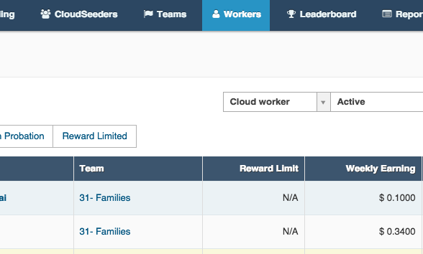
2. Search for the specific worker to whom you have added skills.  
   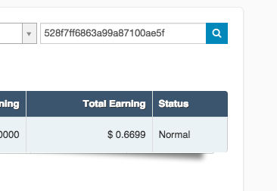
3. Next, check the worker and click masquerade icon.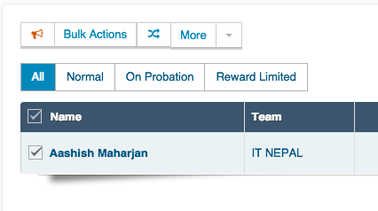
4. Next click Workspace to start receiving task. That’s all  
   